Documentation ( federated Learning) Calculating all result of Fed Methods

FedAvg

Epoch : 15

Num_round = 10

|  |  |  |  |  |  |  |  |  |  |  |
| --- | --- | --- | --- | --- | --- | --- | --- | --- | --- | --- |
| R1 | R2 | R3 | R4 | R5 | R6 | R7 | R8 | R9 | R10 |  |
| 75.94 | 84.16 | 86.53 | 88.45 | 89.06 | 89.85 | 89.76 | 89.77 | 90.01 | 89.71 |  |

FedAdam

Epoch : 15

Num_round = 10

|  |  |  |  |  |  |  |  |  |  |  |
| --- | --- | --- | --- | --- | --- | --- | --- | --- | --- | --- |
| R1 | R2 | R3 | R4 | R5 | R6 | R7 | R8 | R9 | R10 |  |
| 54.94 | 49.17 | 58.62 | 33.95 | 45.67 | 48.99 | 49.01 | 48.78 | 47.11 | 51.12 |  |

FedAdagrad

Epoch : 15

Num_round = 10

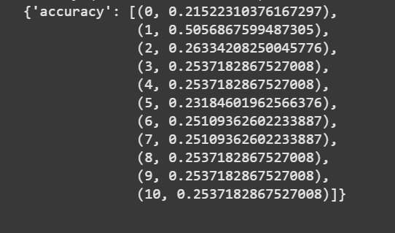

|  |  |  |  |  |  |  |  |  |  |  |
| --- | --- | --- | --- | --- | --- | --- | --- | --- | --- | --- |
| R1 | R2 | R3 | R4 | R5 | R6 | R7 | R8 | R9 | R10 |  |
| 21.52 | 50.56 | 26.33 | 25.37 | 25.37 | 23.18 | 25.10 | 25.10 | 25.37 | 25.37 |  |

FedAvgM

Epoch : 15

Num_round = 10

|  |  |  |  |  |  |  |  |  |  |  |
| --- | --- | --- | --- | --- | --- | --- | --- | --- | --- | --- |
| R1 | R2 | R3 | R4 | R5 | R6 | R7 | R8 | R9 | R10 |  |
| 80.94 | 86.00 | 86.79 | 90.73 | 90.81 | 91.36 | 92.39 | 92.46 | 92.91 | 92.65 |  |

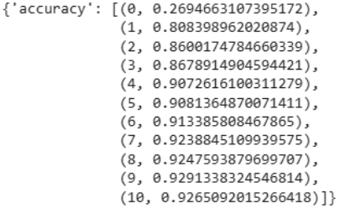

FedMedian

Epoch : 15

Num_round = 10

|  |  |  |  |  |  |  |  |  |  |  |
| --- | --- | --- | --- | --- | --- | --- | --- | --- | --- | --- |
| R1 | R2 | R3 | R4 | R5 | R6 | R7 | R8 | R9 | R10 |  |
| 74.45 | 83.98 | 88.71 | 88.88 | 89.32 | 90.28 | 91.07 | 91.16 | 91.86 | 91.95 |  |

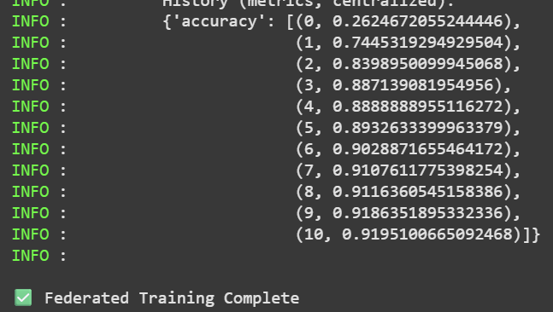

FedOpt

Epoch : 15

Num_round = 10

|  |  |  |  |  |  |  |  |  |  |  |
| --- | --- | --- | --- | --- | --- | --- | --- | --- | --- | --- |
| R1 | R2 | R3 | R4 | R5 | R6 | R7 | R8 | R9 | R10 |  |
| 77.69 | 84.33 | 87.22 | 88.97 | 88.67 | 91.07 | 90.98 | 91.16 | 92.38 | 92.30 |  |

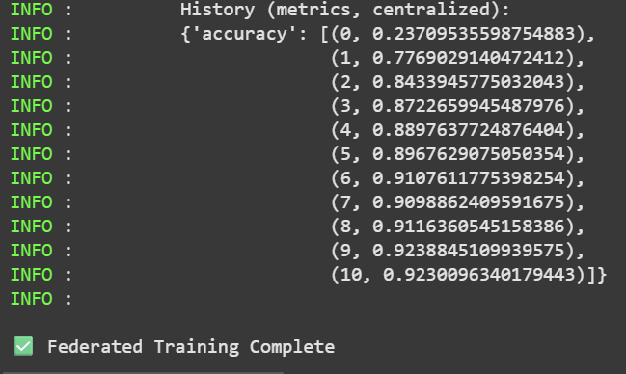

FedProx

Epoch : 15

Num_round = 10

|  |  |  |  |  |  |  |  |  |  |  |
| --- | --- | --- | --- | --- | --- | --- | --- | --- | --- | --- |
| R1 | R2 | R3 | R4 | R5 | R6 | R7 | R8 | R9 | R10 |  |
| 80.31 | 85.56 | 87.48 | 88.80 | 89.67 | 90.55 | 91.60 | 91.42 | 91.60 | 91.86 |  |

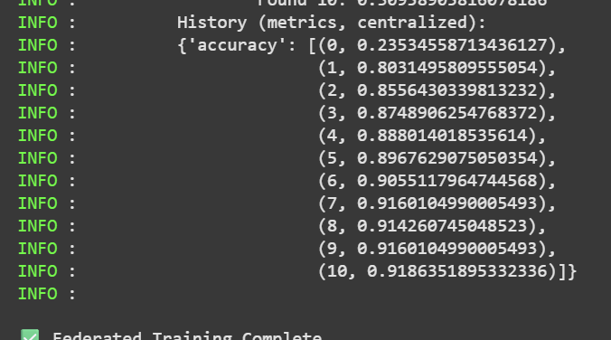

FedTrimmedAvg

Epoch : 15

Num_round = 10

|  |  |  |  |  |  |  |  |  |  |  |
| --- | --- | --- | --- | --- | --- | --- | --- | --- | --- | --- |
| R1 | R2 | R3 | R4 | R5 | R6 | R7 | R8 | R9 | R10 |  |
| 78.74 | 83.98 | 88.10 | 89.15 | 90.37 | 91.51 | 92.12 | 91.77 | 91.51 | 92.82 |  |

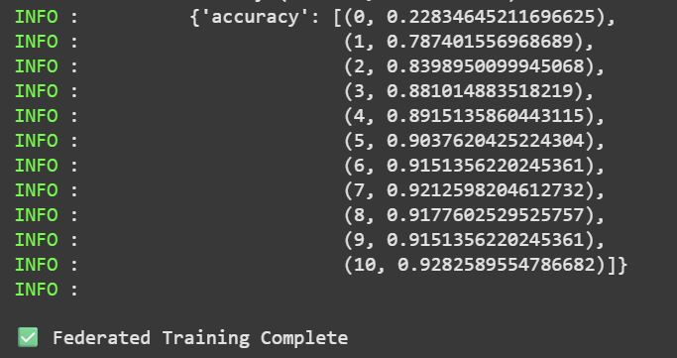

FedYogi

Epoch : 15

Num_round = 10

|  |  |  |  |  |  |  |  |  |  |  |
| --- | --- | --- | --- | --- | --- | --- | --- | --- | --- | --- |
| R1 | R2 | R3 | R4 | R5 | R6 | R7 | R8 | R9 | R10 |  |
| 42.60 | 78.74 | 82.15 | 78.12 | 78.65 | 85.30 | 90.98 | 91.51 | 91.51 | 91.86 |  |

